Measuring the Specific Latent Heat of Fusion of Ice
1. What is the purpose of setting up the funnel of crushed ice and beaker B on the right-hand side?

2. Find the specific latent heat of fusion of ice.

3. Is the result in Question 2 the same as the standard value 3.34 × 10⁵ J kg⁻¹? Account for the difference if any.

Measuring the Specific Latent Heat of Fusion of Ice (Answers)
1. What is the purpose of setting up the funnel of crushed ice and beaker B on the right-hand side?
To work as a control set-up to estimate the amount of ice melted by the heat from the surroundings.

2. Find the specific latent heat of fusion of ice.
In the fully automatic setting,
energy supplied to the heater = 42 465 − 24 465 = 18 000 J;
mass of the ice melted by the supplied energy = 0.076 − 0.027 = 0.049 kg.
Applying 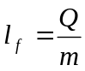, we have 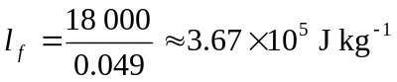.

3. Is the result in Question 2 the same as the standard value 3.34 × 10⁵ J kg⁻¹? Account for the difference if any.
The result in Question 2 is larger than the standard value.
Some energy supplied by the heater is lost to the surroundings.

